SERTO, LLC
At last, Power to the People!

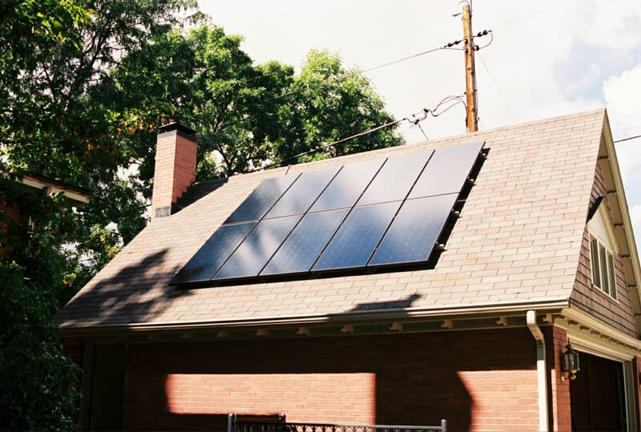

Solar Rent-to-Own Residential PV Program

- Put a Solar-Electric (PhotoVoltaic) System on your roof
- No Money Down
- Sell your excess energy to the utility and turn your meter Backwards – thereby reducing your electric bills
- Pay approximately what your system saves you each month
- Your system can be Paid Off in 10 Years => then you own it
- Lump-sum Payoff Options available – with up to a 20% Discount
- Simple Payment Terms
- Highly-qualified installers ― Licensed, Bonded, Insured
- Over 20 Years of Solar Installation Experience
- System Installation in about 2-3 days

Call _____________________ @ __________________ for a free site visit

WebSite: www.burdicktechnologies.com/SERTO

It’s one small step for the homeowner, one giant leap for energy independence!

