SERTO, LLC
At last, Power to the People!

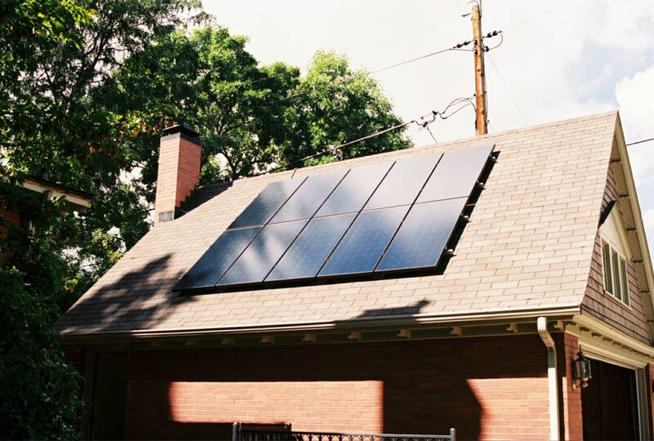

Solar Rent-to-Own Residential PV Program

- Put a Solar-Electric (Photovoltaic) System on your roof
- Sell your excess energy to the utility and turn your meter Backwards – thereby reducing your electric bills
- In many cases, No Money Down — Simple Lease & Buyout Terms
=> pay approximately what your system saves you each month
- Lump-Sum and Short-Term payoff options available: with 15-25%
discounts => a small downpayment is required in this case
- Highly-Qualified installers ― Licensed, Bonded, Insured
- Over 20 Years of Solar Installation Experience
- System Installation in about 2-3 days
- Home Energy Audit and KVAR units available

Call _____________________ @ __________________ for a free site visit

WebSite: www.burdicktechnologies.com/SERTO

It’s one small step for the homeowner, one giant leap for energy independence!

